The Alternative Background Checks

Zach Wetzler

[Zach Wetzler](https://blog.verif-y.com/author/zach-wetzler)

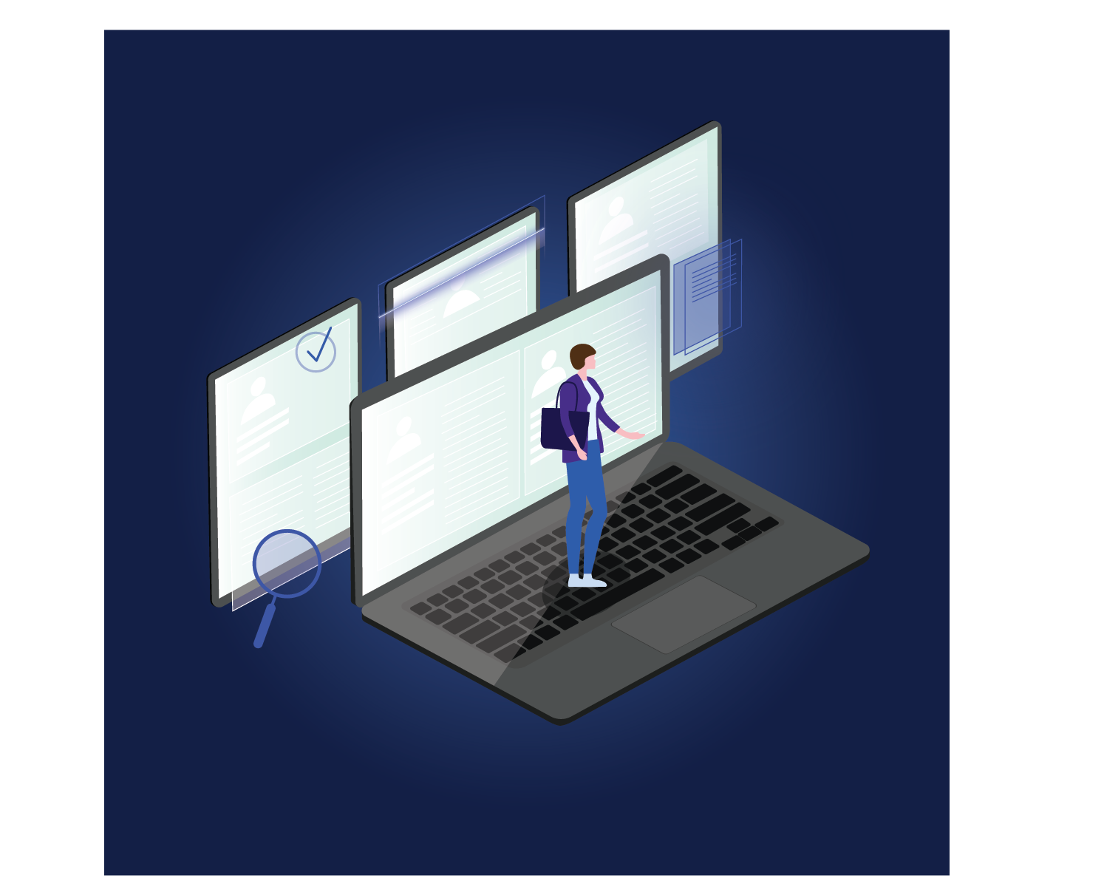

**What Are Background Checks?**

[Background checks](https://blog.verif-y.com/what-are-background-checks-and-how-have-they-changed) are a customary part of any hiring process. Background checks help companies to address workplace safety and avoid threats. They are key initiatives for any company during the pre-employment evaluation process. Running background checks allows companies to investigate a variety of data points that will affect their hiring decision. Contingent upon need and industry, companies frequently search criminal records, perform drug screenings, evaluate work and academic history, financial history, and much more to gain reassurance. While background checks [date back to the early 1900's](https://blog.verif-y.com/what-are-background-checks-and-how-have-they-changed), alternative background checks have been used in conjunction to the classic method in recent years.

**How Can Background Checks Help Organizations?**

Verifying potential employee’s criminal histories and credentials helps your business adhere to the latest FCRA regulatory requirements, is critical to saving money, and protects your company’s reputation. Those companies who forgo pre-employment background checks invite potential for fraud. Regardless of your organization’s process, our constantly changing and digital world continues to spark the need for additional screening technology and opportunity.

**Has The Pandemic Affected The Process?**

First and foremost, the COVID 19 pandemic has considerably altered the ease of running some standard background check processes. Increased remote work, a gig economy boom and other obstacles caused by the pandemic necessitated companies to change. Court closures across the country delayed background check procedures and made them difficult to run.

Additionally, in 2021 state DMVs partially suspended certain MVR checks and regional courts provided limited access to important records. Employment verification checks became harder to perform as offices closed or went virtual. This collective struggle not only showed companies the importance of employee background checks but also emphasized the need for additional screenings that could be done in spite of a global pandemic.

Such alternative background check methods include:

* + [**Identity Verification Screening**](https://www.verif-y.com/services/identity-verification/): Employers can now leverage cutting edge AI and OCR technology to verify applicant identity details in minutes. This type of service is particularly relevant for those firms hiring employees remotely or with whom they do not consistently interact with. In addition to traditional methods, unknown gig workers should be scanned using remote onboarding tools. Employers can now benefit from a multitude of  new, easy to integrate solutions to run checks to ensure that their contractors and employees are authenticated and are who they say they are. Implementing such measures not only increases safety but also increases customer reassurance.
  + [**Social Media Search**](https://www.verif-y.com/services/identity-verification/): In light of an increase in lewd or hateful online activity, many employers are considering social media an important new source for screening applicants. Employers should make sure that their applicants published actions and expressions are not discriminatory nor promote violence. Verif-y provides an added layer of confidence through a permissioned, deep social analysis by checking that potential employees are in line with organizations' values and conduct policies through their digital footprints.
  + [**Skills Verification**](https://www.verif-y.com/services/identity-verification/): The way in which technology companies evaluate talent is changing. Employers who once required that applicants hold degrees have decided to refocus, and now judge applicants based on skills. This is a win-win for both employers and applicants. Employers can now more thoroughly evaluate applicants based on their core abilities and can begin to hire from a more diverse pool of talent. While qualified applicants—previously blocked by inequity and other barriers—are now more likely to secure roles as they demonstrate verified skills certificates from online courses or training centers.



The purpose behind each of these new background check practices is related to Verif-y’s mission. Each either promotes transparency or ultimately enables a more streamlined exchange of verified data. The verifications performed during background checks serve as building blocks towards an individual’s digital identity.

[Find Out More](https://blog.verif-y.com/cs/c/?cta_guid=a55fc533-7433-483f-9d13-b0b37e86975e&signature=AAH58kE85d5wXfBN-J-S4A8FfXOSaVsBVw&pageId=51746422153&placement_guid=afed1c44-a70d-4093-a8a2-0e806e148747&click=4c2d567c-4dd6-474d-90ca-81e708792497&hsutk=9d11a544117a53686af606949393a9eb&canon=https%3A%2F%2Fblog.verif-y.com%2Fthe-alternative-background-checks&utm_referrer=https%3A%2F%2Fblog.verif-y.com%2F&portal_id=9009840&redirect_url=APefjpHc_iMztXkWqiP1oPaqWJ2-nwdQNh0Zodhr6tMDyxgLgG6D9XtUN-4sko22L4qSG0AimrPeizfsQ9FtNow2jtSLxa6I8qMiMYd-fmYuXQEw4GVpCc13Tqajj7eyHaBEW5mZ7DvZAYkE1RIw0yqcy1IleWPW9ETg-N5eECSMRwf7sW4VO24KiACJ6scBgDADr_6w5XuGuH9MSMbPNlmOJXi7xPMNDleTaxBGJBIytctcK6UE8vLsTBfjnFFNeTYMRzMdU9qQ14y8NY3BQvmy78Y53B_lurRG3uVyr0V1FebHSUwNQCk&__hstc=66120369.9d11a544117a53686af606949393a9eb.1649849487414.1657630774363.1657633078290.50&__hssc=66120369.11.1657633078290&__hsfp=980283150&contentType=blog-post" \o "Find Out More" \t "_blank)